Studio # 5 & 6

Name and Student Id: Nicolas Pallant 28785959

Self-Evaluation

|  |  |  |  |  |  |
| --- | --- | --- | --- | --- | --- |
| Need Help | Work in Progress | Pass | Credit | Distinction | High Distinction |

Task 5.1

Notify WebApp

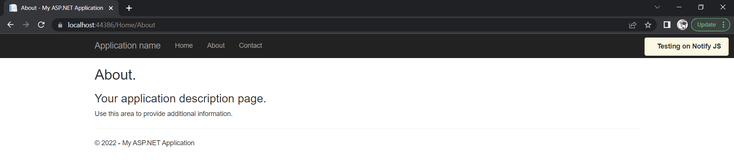

Notify Code

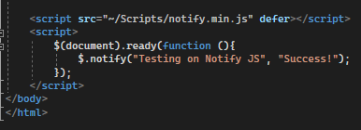

Defer vs async

Both aync and defer make sure that scripts don’t block the page from rendering so that the user can immediately begin browsing, even if the scripts aren’t functional immediately.

Defer means that the script will wait until the entire page has loaded first, and will be executed last, right before DomContentLoaded. Defer should be used for scripts that rely on the entire document, or when the loading/execution of the scripts is important.

Async will begin executing as soon as they appear in the order of the page, so if they are called first and are small enough, they may be loaded before the webpage is actually displayed to the user. Async should only be used for scripts that don’t reply on other scripts, or content on the page, such as advertisements.

Git Repository

https://github.com/Ryukawastaken/FIT5032-Internet-Apps-Dev

Task 5.2

Datepicker Screenshot

Git Repository

https://github.com/Ryukawastaken/FIT5032-Internet-Apps-Dev

Task 6.1

Screenshot of Web Application

Screenshot of Code

Git Repository

https://github.com/Ryukawastaken/FIT5032-Internet-Apps-Dev

Task 6.2

jQuery unobstructive validation is an improvement on the original jQuery validate plugin. It makes it so that you do not need to repeat yourself with the validation steps, as in normal jQuery validation, you have to put the same logic in two separate places.

MVC includes jQuery unobstructive validation by default and it doesn’t add any additional client time loading. Client side validation is very important as it increases the user experience by giving the users instant feedback, and not making them wait for the server to send back the packets.

This is important to ViewModels as it means all of the validation logic in the ViewModels will be automatically generated from either the Database or the C# class.